Solving SQL Question In Big QUERY
Basic Question and solution in Big query

1) Select all columns from the Customers table.
Query :- SELECT * from `core-folio-462704-q6.Customer_data.Ecommerce Customers`;

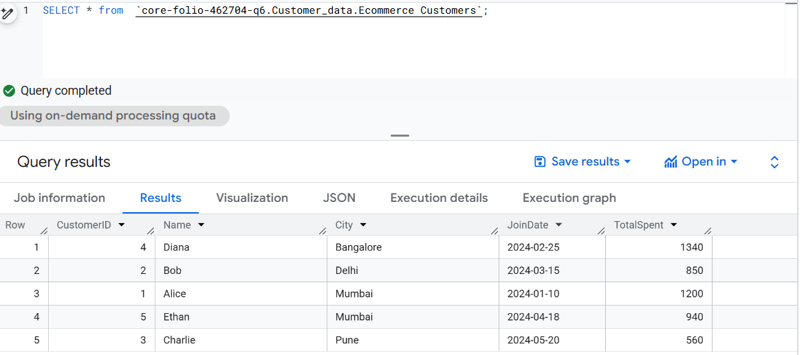

2) Find all orders where the quantity is greater than 1.
Query :- SELECT * from `core-folio-462704-q6.Customer_data.Orders `
Where Quantity >1;

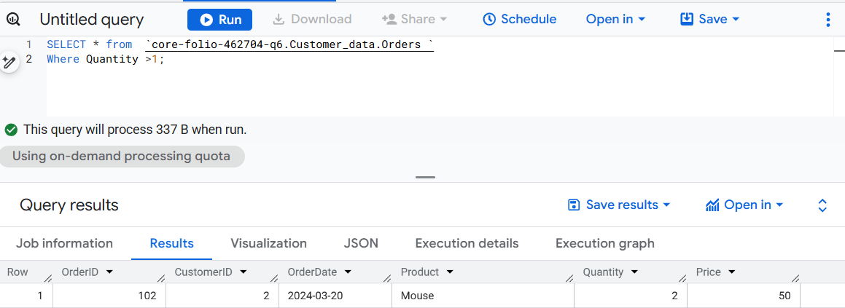

3) List the Name and City of customers who joined after 2024-03-01.
Query :- SELECT Name ,City from `core-folio-462704-q6.Customer_data.Ecommerce Customers`
Where JoinDate > '2024-03-01';

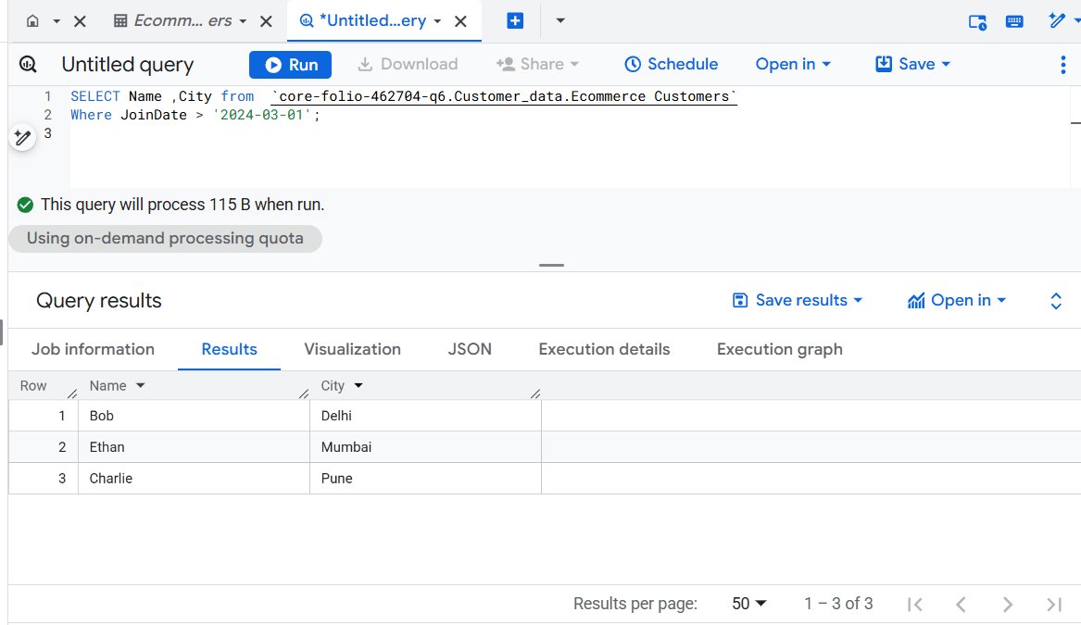

4 ) Count the total number of orders.
Query :- SELECT Count(*) As Total_orders from `core-folio-462704-q6.Customer_data.Orders `;

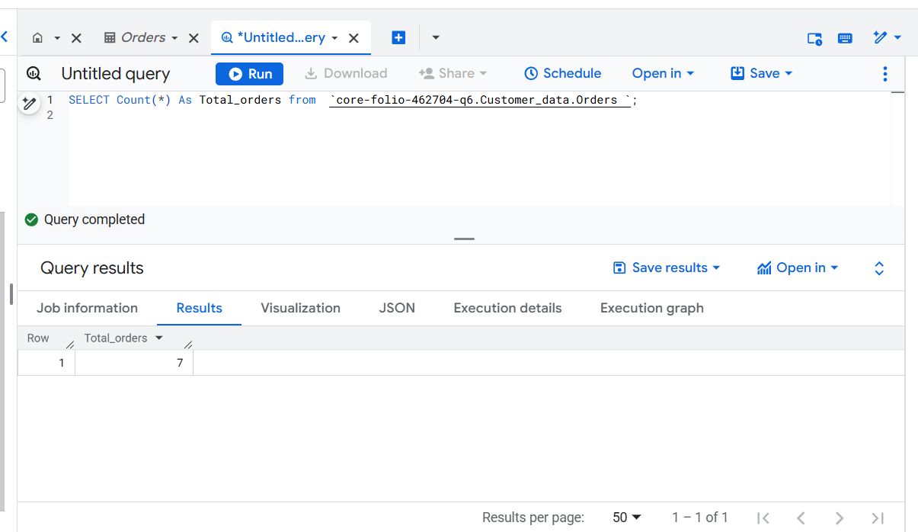

5 .)Find the maximum, minimum, and average price of products in Orders and arrange the product in Ascending.

Query :- SELECT Product,Max(Price) As Max_price,MIN(Price) As Min_Price,AVG(Price) As Average_price from `core-folio-462704-q6.Customer_data.Orders `
Group By Product
Order By Product ASC;

